A Minor Project Synopsis on

**Breast Cancer Detection Using Machine Learning Algorithms**

Submitted to Manipal University, Jaipur

Towards the partial fulfillment for the Award of the Degree of

**BACHELOR OF TECHNOLOGY**

In Computer and Communication Engineering

2022-2023

By

Arjun Raghav

Registration Number: 209401016



Under the guidance of

Dr. Rohit Mittal

**Department of Computer and Communication Engineering**

**Manipal University Jaipur**

**Jaipur, Rajasthan**

**Introduction:**

According to a study done in 2020 by the World Health Organization, there were 2.3 million women diagnosed with breast cancer and 685,000 deaths globally making it the worlds most prevalent cancer. Utilization of machine learning algorithms can go a long way in the prediction and early detection of this disease which is extremely important. The traditional mode of detection i.e., manually interpreting mammographs can be subject to human error and unable to detect small and subtle changes. As a result, there is a need for more accurate and reliable methods of breast cancer detection that can help improve patient outcomes. Application of machine learning has the potential to address these limitations and make further improvements. Machine learning algorithms can be trained on large amounts of data such as mammography images, to identify features and patterns that are indicative of breast cancer. This can lead to a more accurate and early diagnosis. Automating certain parts of the diagnostic process can also help to reduce the burden on radiologists which allows them more time to focus on more complex cases. While there is still much work to do in this area, the potential benefits of using machine learning in breast cancer detection are significant. From increasing the accuracy of the diagnosis to reducing the burden on healthcare professionals, machine learning can have a significant impact on the way breast cancer is detected and treated. While there is still much work to be done in this field, the potential benefits of using machine learning for detection of breast cancer are significant. From improving the accuracy of diagnosis to reducing the burden on healthcare professionals, machine learning has the potential to have a profound impact on the way breast cancer is detected and treated.

**Motivation:**

The motivation of this project is to help improve the accuracy and efficiency of breast cancer diagnosis. It is the most prevalent cancer and unlike some other cancers, breast cancer does not have any known viral or bacterial links to its development. In fact, half the breast cancer cases are women who have no identifiable risk factors other than their gender and age. Here an early detection is extremely important for an increase in the success rate of treatment, but traditional methods of breast cancer detection such as mammography, have limitations in terms of accuracy and reliability. As a result, there is a need for more accurate and reliable methods of breast cancer detection that can help to improve patient outcomes and reduce the burden on doctors. Machine learning can help address these limitations and improve the quality of breast cancer diagnosis. Most importantly:

* Improve the accuracy and reliability of diagnosis.
* Facilitate the early detection so as to improve patient outcomes.
* Automate the process to reduce the burden on radiologists.
* Improve the quality of life and potentially save lives of breast cancer patients.
* Development of new technologies and approaches can also benefit in detection and treatment of other forms of cancer

**Objectives:**

The objective of using machine learning algorithms to detect breast cancer is to improve the accuracy and efficiency of the diagnostic process. Specifically:

1. Develop an accurate classification model: The primary objective of breast cancer detection using machine learning algorithms is to develop a model that can accurately classify patients as either having breast cancer or not. This involves training the model on a large dataset of medical images and patient data to identify patterns and features that are indicative of breast cancer.
2. Improve diagnostic efficiency: By leveraging the power of machine learning algorithms, the goal is to improve efficiency of breast cancer diagnosis. A well-trained machine learning model can help healthcare professionals identify potential cases of breast cancer earlier, which can lead to more effective treatment and improved patient outcomes.
3. Reduced burden on doctors- Automation of the diagnostic process will reduce the burden on doctors to diagnose so many cases manually and instead will leave them more time to focus on the appropriate treatment and more complex cases.

**Research Methodology:**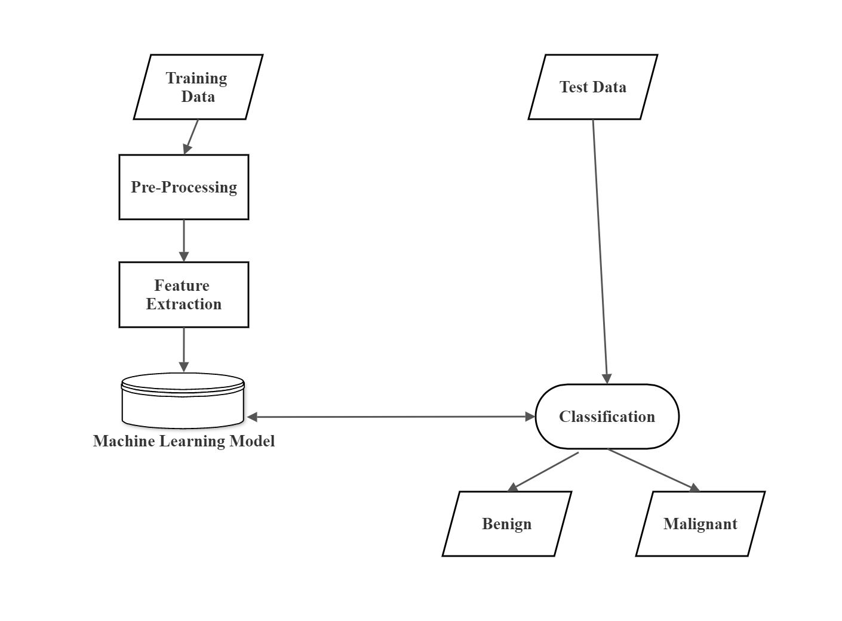

1. Training Data- The first step is to gather a collection of medical images such as mammograms as well as any other accompanying clinical data
2. Pre-Processing- Preprocessing of the data is done to ensure that it is standardized and ready for analysis
3. Feature Extraction- Extraction of features from the dataset which are indicative of the presence of tumors to determine the occurrence of cancer
4. Machine Learning Model- Apply a machine learning model and train it using the available dataset
5. Test Data- After the model has been trained on an a large amount of dataset, testing is done so as to check whether accurate diagnosis is being made
6. Classification- On running the machine learning model the data is interpreted and classified as an indicator of presence of breast cancer (malignant) or absence (benign)

**Facilities Required:**

Software:

* Python
* Machine learning libraries such as PyTorch and TensorFlow
* Windows 11 Operating System

Hardware:

* 256 MB RAM
* Intel® Core™ i5-8350U
* 1 GB free drive space

**Bibliography/References:**

* https://www.who.int/news-room/fact-sheets/detail/breast-cancer
* https://www.mayoclinic.org/diseases-conditions/breast-cancer/symptoms-causes/syc-20352470
* https://www.cancer.org/cancer/breast-cancer/about.html
* https://www.bcrf.org/breast-cancer-statistics-and-resources/
* https://towardsdatascience.com/building-a-simple-machine-learning-model-on-breast-cancer-data-eca4b3b99fa3
* https://www.healthline.com/health/breast-cancer#diagnosis